****LAB # 1****

INTRODUCTION TO NETWORK Devices

OBJECTIVE

# Introduction of network devices and basic terminologies.

# THEORY

InTERNET

The**internet** is a global network of computers that works much like the postal system, only at sub-second speeds. Just as the postal service enables people to send one another envelopes containing messages, the internet enables computers to send one another small packets of digital data.

InTRANET

An **intranet** is a private enterprise network, designed to support an organization’s employees to communicate, collaborate and perform their roles. It serves a broad range of purposes and uses, but at its core, an intranet is there to help employees.

NETWORK DEVICES

**HUB**

A **network hub** is a device for connecting multiple twisted pair or fiber optic Ethernet devices together and thus making them act as a single network segment. Hubs work at the physical layer (layer 1) of the OSI model. The device is thus a form of multiport repeater. Repeater hubs also participate in collision detection, forwarding a jam signal to all ports if it detects a collision.

Hubs also often come with a BNC and/or AUI connector to allow connection to legacy 10BASE2 or 10BASE5 network segments. The availability of low-priced network switches has largely rendered hubs obsolete but they are still seen in older installations and more specialized applications.

A network hub is a fairly unsophisticated broadcast device. Hubs do not manage any of the traffic that comes through them, and any packet entering any port is broadcast out on all other ports. Since every packet is being sent out through all other ports, packet collisions result—which greatly impedes the smooth flow of traffic.

Technically speaking, three different types of hubs exist:

1. ***Passive*** (A hub which does not need an external power source, because it does not regenerate the signal and therefore falls as part of the cable, with respect to maximum cable lengths)
2. ***Active*** (A hub which regenerates the signal and therefore needs an external power supply)
3. ***Intelligent*** (A hub which provides error detection (e.g. excessive collisions) and also does what an active hub does)

[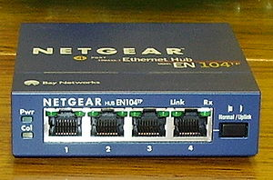](http://en.wikipedia.org/wiki/File:4_port_netgear_ethernet_hub.jpg)

**Fig 1.1** 4-port Ethernet hub

**SWITCH**

Switches are often confused with bridges because they also operate at the [data link layer](http://en.wikibooks.org/wiki/Network_Plus_Certification/Management/OSI_Model#Data_Link) of the [OSI model](http://en.wikibooks.org/wiki/Network_Plus_Certification/Management/OSI_Model). Similar to a hub, switches provide a central connection between two or more computers on a network, but with some intelligence. They provide traffic control for packets; rather than forwarding data to all the connected ports, a switch forwards data only to the port on which the destination system is connected. They use a database of [MAC (Media Access Control) addresses](http://en.wikibooks.org/wiki/Network_Plus_Certification/Technologies/Addressing_Formats#MAC_.28Media_Access_Control.29_addressing) to determine where computers are located and very efficiently send packets only where they need to go. The database is created dynamically as computers communicate on the network. The switch simply watches the incoming packets and memorizes the MAC address and port a packet arrives on. If a packet arrives with a destination computer that the switch does not have an address for in its MAC address table, it will flood the packet out all connected ports. A switch creates separate collision domains for each physical connection. A switch will only create separate broadcast domains if separate [VLANs](http://en.wikibooks.org/wiki/Network_Plus_Certification/Devices/Advanced_Switching#VLAN_.28Virtual_Local_Area_Network.29) (Virtual Local Area Networks) are assigned to different ports on the switch. Otherwise, a [broadcast](http://en.wikibooks.org/wiki/Network_Plus_Certification/Technologies/Addressing_Methods#Broadcast) received on one port will be flooded out all ports except the one it came in on.

[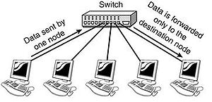](http://en.wikibooks.org/w/index.php?title=File:Switch.JPG&filetimestamp=20051128030121)

**Fig 1.2** Interconnection of workstations with switch

**BRIDGE**

Bridges can be identified by the fact that they operate at the [data link layer](http://en.wikibooks.org/wiki/Network_Plus_Certification/Management/OSI_Model#Data_Link) of the [OSI model](http://en.wikibooks.org/wiki/Network_Plus_Certification/Management/OSI_Model). Bridges have intelligence and can "bridge" two of their ports together at very high speed. They use a database of [MAC addresses](http://en.wikibooks.org/wiki/Network_Plus_Certification/Technologies/Addressing_Formats#MAC_.28Media_Access_Control.29_addressing) to determine where computers are located and very efficiently send frames only where they need to go. The database is created dynamically as computers communicate on the network. A bridge simply watches the incoming frame and memorizes the MAC address and port a frame arrives on. It uses this information to locate a computer if a packet comes in that must be forwarded to it. If a frame arrives at the bridge and the bridge does not know where to send it, the bridge will flood the frame just like a hub does. Bridging is often inaccurately called switching.

[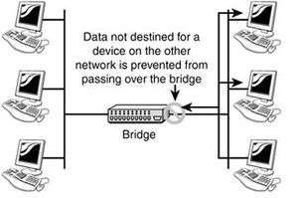](http://en.wikibooks.org/w/index.php?title=File:Bridge.JPG&filetimestamp=20051128030438)

**Fig 1.3** Bridge connecting LAN segments

**MODES OF COMMUNICATION**

There are 3 types of transmission modes which are given below: Simplex mode, Half duplex mode, and Full duplex mode. These are explained as following below.

1. **SIMPLEX MODE:**  
   In simplex mode, Sender can send the data but that sender can’t receive the data. It is a unidirectional communication.

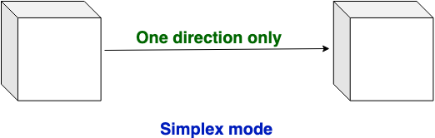

1. **HALF-DUPLEX MODE:**  
   In half duplex mode, Sender can send the data and also can receive the data but one at a time. It is two-way directional communication but one at a time.

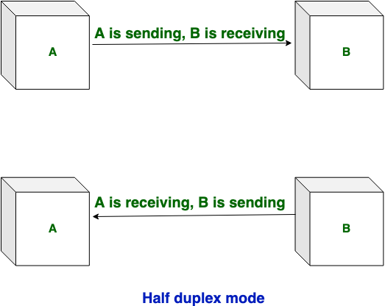

1. **FULL DUPLEX MODE:**In full duplex mode, Sender can send the data and also can receive the data simultaneously. It is two-way directional communication simultaneously.

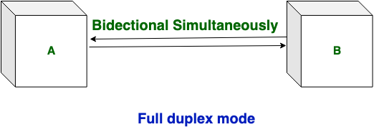

**HOME ASSIGNMENTS**

Q1: Differentiate between manageable and unmanageable switches/bridges.

Q2: Describe the different types of ports in manageable switches.

Q3: Difference between Layer 2 and Layer 3 switches.

Q4: Difference between three modes of communication.